**Analysis of Admob Data**

This report presents an analysis of Admob data aimed at understanding advertising performance metrics and providing insights for optimizing ad strategies. The dataset includes information such as estimated earnings, observed eCPM, requests, impressions, clicks, and bid-related metrics across various countries and time periods.

**Key Findings:**

## **Section 1: Basic Data Analysis**

**Q1: Top 10 Revenue Generating Countries in 2023:**

* Libya: Generated the highest revenue with $76.21 USD.
* Tanzania: Followed closely with $73.07 USD in revenue.
* Cameroon: Generated $51.42 USD in revenue.
* Pakistan: Accumulated $40.01 USD in revenue.
* Czechia: Generated $28.41 USD in revenue.
* Congo - Brazzaville: Followed closely with $28.38 USD in revenue.
* Sweden: Accumulated $26.53 USD in revenue.
* Liberia: Generated $20.58 USD in revenue.
* United States: Earned $19.88 USD in revenue, ranking ninth in the list.
* Gabon: Rounded up the top 10 with $18.98 USD in revenue.

**Q2: Cumulative distribution of impressions across each month throughout the years of available data (i.e.**

* **2021**:
  + In January, there were 1171 impressions.
  + The number of impressions increased gradually over the months, reaching a cumulative total of 40089 impressions by December.
* **2022**:
  + Impressions started at 4196 in January and increased steadily over the year.
  + By December, the cumulative total reached 83441 impressions.
* **2023**:
  + The data only includes impressions up to July 2023.
  + Impressions started at 5733 in January and increased month by month, reaching 37796 impressions by July.

## **Section 2: Data Visualization**

**Q1: Create column charts that depict the second & third tasks above.**

* **2021**: Impressions steadily increased throughout the year, starting at 1171 in January and reaching 40089 by December. There is a clear upward trend in impressions over the course of the year, indicating consistent growth in ad visibility and engagement.
* **2022**: Impressions continued to grow significantly in 2022, with a higher starting point of 4196 in January compared to the previous year. The cumulative impressions increased steadily each month, peaking at 83441 by December. This suggests sustained momentum in ad performance and user engagement throughout the year.
* **2023**: The data for 2023 covers impressions up to July. Impressions started at 5733 in January and increased steadily each month, reaching 37796 by July. Although the data only covers the first seven months of the year, the trend indicates continued growth in ad visibility and engagement compared to previous years.

**Q2: Create a line chart illustrating the trend of impressions in 2023.**

* **Trend of Impressions in 2023:**
  + The data represents the trend of impressions throughout the year 2023, spanning from January 1st to July 23rd. Impressions refer to the number of times an ad is displayed or viewed. Looking at the numbers, I can observe fluctuations in impressions over time.
  + On January 2nd, there were 316 impressions, indicating a relatively high level of ad visibility on that day. Conversely, on July 23rd, there were only 48 impressions, suggesting a decrease in ad visibility compared to previous days.
  + This trend provides valuable insights into the performance and effectiveness of advertising campaigns throughout the year. Analyzing such data helps advertisers and marketers understand the impact of their advertising efforts and optimize strategies to reach their target audience more effectively.

**Q3: Develop a bar chart comparing the performance of different ad formats (i.e. banner ads vs. interstitial ads vs. rewarded ads) in terms of Revenue.** 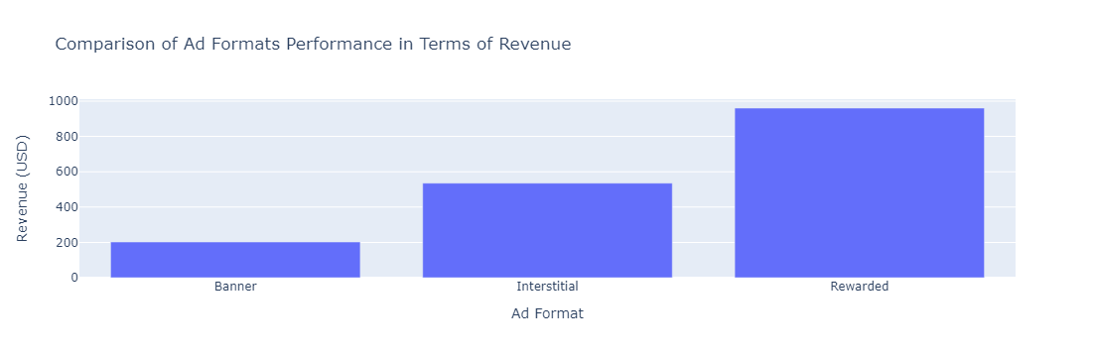

The revenue data for different ad formats is as follows:

* Banner: $202
* Interstitial: $535
* Rewarded: $960

## **Recommendations**

Based on the analysis, the following recommendations are proposed for optimizing ad strategies:

1. **Target High-Revenue Generating Countries:**
   * Focus advertising efforts on high revenue generating countries identified in the analysis, such as Libya, Tanzania, and Cameroon.
   * Allocate budget and resources to capitalize on the growth potential of these markets and tailor ad content to resonate with local audiences.
2. **Optimize Ad Placement and Timing:**
   * Utilize insights from the cumulative distribution of impressions across months to optimize ad placement and timing.
   * Target peak periods of advertising demand and user engagement to maximize ad visibility and effectiveness.
3. **Monitor and Adjust Ad Campaigns:**
   * Continuously monitor ad performance metrics and user engagement trends to identify opportunities for optimization.
   * Regularly review and adjust ad campaigns based on real-time data insights to ensure relevance and effectiveness.

In conclusion, the analysis of Admob data provides valuable insights into advertising performance metrics and trends. By leveraging these insights and implementing the recommended strategies, advertisers can optimize ad campaigns to enhance reach, engagement, and revenue generation.